
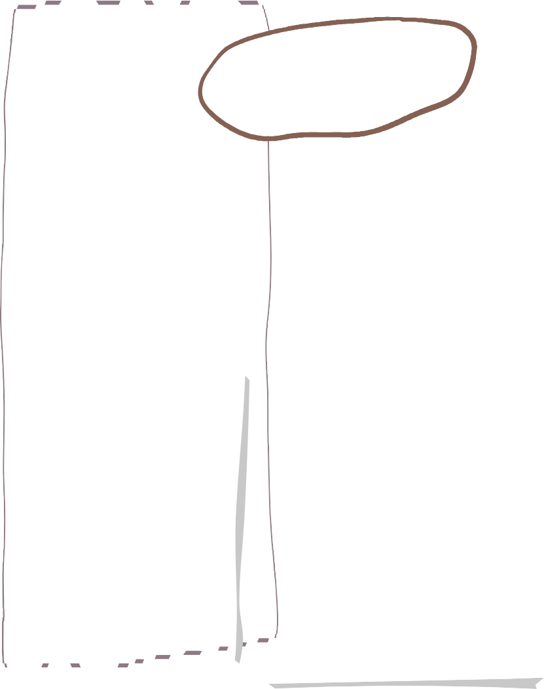







Autumn One in CLASS 1
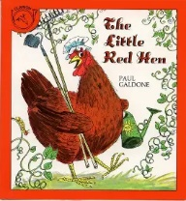
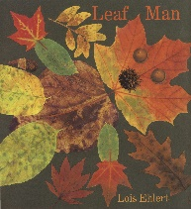

Monday 28th September- Reception
Parents phonics information session.
3:30pm in our classroom.

PE will be on a Thursday and Friday. Reception/Year 1 children will get changed in school. Preschool children should come dressed appropriately if they are in on those days, or bring trainers.

Our Topic this half term:
Mathematics
Notices

‘Me, my world and belonging’

Our weekly mini-topics
🏫 Me at School → Settling in & belonging
🪞 Me → Unique and special
🏠 My People → Families & relationships
❤️ My Feelings → Emotions & well-being
🍂 My World → Autumn & Harvest
✨ Wonder & Imagination → Halloween, magic & potions

We also follow the children’s interests and plan using this.
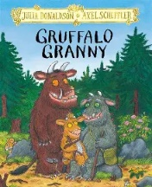
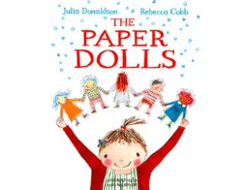

Homework and phonics book change will take place on a Friday.

Reception books and Reading Records will be sent out on Monday 14th September and will be wordless to begin with until we have correctly secured all of our sounds. More information on how to support your child in reception will be shared at the Phonics session above.

Books we will be reading:

Nursery
Can I find more than, fewer than and the same number of objects?

Reception:
Can I develop secure counting, subitising and comparison? Can I explore numbers to 5 and beyond through practical experiences?
Year 1:
Can I count, read and write numbers to 10?
Can I identify one more and one less and compare numbers using mathematical language?


Personal, Social, Emotional Development
Nursery: Can I develop responsibility and membership of community?
Can I be more outgoing with unfamiliar people?
Can I show confidence in new social situations?
Reception:
Can I build positive relationships with adults and peers?
Can I recognise and talk about feelings?
Can I develop independence in routines?
Year 1:
Can I understand why classroom rules are important?
Can I develop respectful friendships and listen to others?

•







Nursery
Can I join in with rhymes and repeated phrases?
Reception:
Can I learn set 1 sounds m, a, s, d, t, i, n, p, g, o, c, k, u, b, f, e, l, sh, h, r, j, v, w, x, y, z, th, ch, qu, ng, nk?
Year 1: -Can I sound out most phonemes and I am able to identify common digraphs (Phase 2 and 3)?
-Can I blend simple CVC, CVCC words?

Literacy
Communication and Language
Reading
Nursery:
•Can I begin to make marks to represent my ideas?
•Can I give meaning to my marks and drawings?

Reception:
Can I develop a love of books and talk about stories, characters and events?
Can I begin to hear and identify sounds in words and use marks and letters to communicate?
Year 1:
Can I apply phonics to decode words and read simple texts fluently?
Can I develop comprehension through discussion and respond to what I have read?
Nursery:
Can I begin to listen and respond to simple instructions and questions?
Can I develop confidence in speaking and taking turns in conversations?
Can I learn and use new vocabulary through stories, songs and play?
Reception:
Can I listen carefully, follow instructions and develop confidence in conversations?
Can I learn and use new vocabulary?
Year 1:
Can I listen and respond appropriately in discussions?
Can I ask and answer questions and express ideas clearly?

Understanding the World (Nursery and Reception)
Science, Geography and History (Year 1)
Nursery and Reception
Can I explore my family, home and local area? Can I talk about people who are important to me and notice similarities and differences between myself and others? Can I begin to notice seasonal changes?
Year 1
Science- Seasonal Changes- Can I observe changes across the four seasons and observe and describe weather associated with the seasons?
History- Can I talk about changes within living memory and use photographs, objects and personal experiences to explore how life has changed over time?
Geography- Can I use simple geographical vocabulary to describe their local area. Use simple maps and fieldwork to explore the school and its surroundings?

Nursery:
Can I begin to develop confidence and control when moving in different ways?
Can I begin to develop coordination and increasing independence when using hands and fingers for fine-motor activities such as cutting and threading?

Reception:
Can I develop balance, coordination and control through running, jumping, climbing and movement?
Can I develop increasing independence in fine-motor tasks by using the correct pencil grip?
Year 1:
Can I develop running, jumping and coordination skills and begin to apply these in different activities and games?
Physical Development

Nursery:
Can I make marks and give meaning behind them?
Can I engage in role play with increasing confidence?
Reception:
Can I explore colour, texture, music and different materials to express ideas and experiences?
Can I develop imaginative role play?
Year 1
Can I use drawing, painting and sculpture to develop and share ideas?
Can I explore colour, pattern, texture, line, shape and form?

Expressive Arts and Design

